Supportive learning environment: Catering for diversity
The Australian Professional Standards for Teachers identifies seven Standards that describe what ‘teachers should know and be able to do. The Standards are interconnected, interdependent and overlapping’ (AITSL, 2014). The required skills for effective, quality teaching practices are described as focus areas within each of the standards. The Standards are broadly organised within three domains of teaching: Professional Knowledge, Professional Practice and Professional Engagement.
While it is clear that this unit of work would draw on teaching skills across all of the Standards, the particular focus of this supporting document is aligned to those required to create and maintain supportive and safe learning environments (Standard 4) within the domain of Professional Practice.
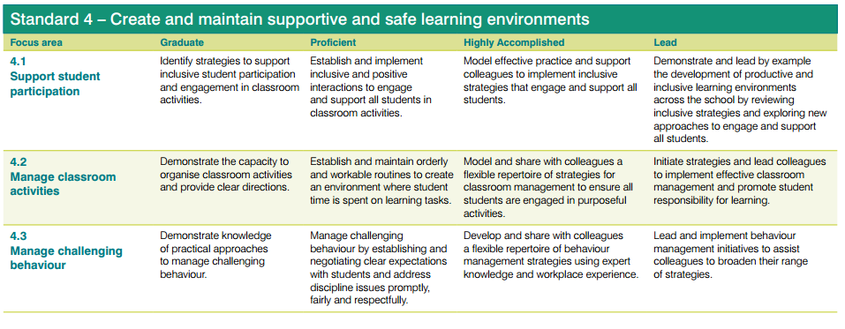
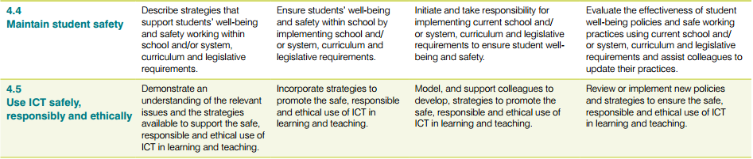
Other Standards of particular relevance when considering differentiated, targeted and intensive support options would be those from the Professional Knowledge domain:
- Know students and how they learn
- Know the content and how to teach it

The Queensland Studies Authority (2010) identifies a supportive and inclusive learning environment as one that:
- Values diversity of ability, opinion and experience
- Values diversity of language and cultural beliefs
- Is supportive of everyone’s efforts
- Empowers everyone to communicate freely

Strategies and adjustments to engage and support all students
Adjustments in environment
- Seat students with specific needs in optimal location for learning (e.g. student with hearing loss close to teacher and away from ambient noise)  - Provide quiet working space for independent activities | - Monitor playground situation and support student to choose activities that assist them to interact with others in a safe and engaging way  - Provide specialised work area where students can engage with concrete materials
Adjustments in planning
- Plan with other specialists such as speech pathologists, guidance officers, special education teachers to incorporate targeted individual goals  - Plan to explicitly teach curriculum content |  | - Plan for personalised learning and support. Consider an Individual Support Plan for those students requiring differentiated curriculum to support access, participation and achievement  - Plan access to rewarding activities
Adjustments in teaching
- Provide a continuum of support to respond to the learning needs of all students by working within a Whole-school approach to supporting student learning (Department of Education and Training, 2013)  - A Whole-school approach to supporting student learning | - Increase opportunities to practise new skills and concepts  - Provide additional modelling, concrete examples, visual and pictorial supports such as graphic organisers, link to prior knowledge, human resources (peer tutoring, teacher aides), cycle of practice and feedback at all stages  - Consult with specialist staff to integrate low tech and high tech communication supports where required. (For further information, see sites and documents such as the Visual Supports Guide from the Downs Syndrome Association of Queensland for descriptions of a range of low tech communication support options and Spectronics: Inclusive Learning Technologies for reviews and descriptions of communication devices and apps  - Reduce the amount and complexity of materials and texts  - Break tasks into smaller achievable tasks  - Incorporate software options to support literacy such as Read&Write Gold or turning on the Text to Speech features in Accessibility options (e.g. Narrator for the computer or Speech on iPad)
Adjustments in assessment
- Use technology to record student work  - Collect annotated work samples  - Clearly articulate goals at the commencement of the unit of work  - Assess against appropriate criteria. For example, may be against a different year level if student on Individual Support Plan | - One-to-one conferencing  - Find alternative ways of demonstrating competency e.g. use of augmentative or alternative communication system for students with spoken communication disorders
Supporting classroom engagement and participation
- Align teaching practice and behaviour expectations with the identified school-wide approach to creating a safe, supportive and disciplined school for your school  - Consider developing explicit skills in behaviour management e.g. Essential Skills for Classroom Management | - Reflect on management strategies (e.g. journal, mentor discussion)  - Be aware of impact of your own words and actions  - Improve your understanding of behaviour  - Develop checklist for identifying behaviours and triggers  - Affirm appropriate behaviour and assertively correct inappropriate behaviour  - Develop portfolio of behaviour management strategies and resources  (Churchill et al, 2013, p. 398 – 405)
Websites:
Australian Government (Department of Education and Training). (n.d). Planning for Personalised Learning and Support: A National Resource. https://docs.education.gov.au/system/files/doc/other/planningforpersonalisedlearningandsupportnationalresource.pdf
Australian Institute for Teaching and School Leadership (AITSL). (2014). http://www.aitsl.edu.au/australian-professional-standards-for-teachers/standards/list
Downs Syndrome Association of Queensland http://www.dsaq.org.au/info-and-support-pages/communication
Spectronics: Inclusive Learning Technologies https://www.spectronics.com.au/
State of Queensland (Department of Education and Training). (2016). Behaviour:
A school-wide approach to creating a safe, supportive and disciplined school (2015)
http://education.qld.gov.au/behaviour/index.html
State of Queensland (Department of Education and Training). (2016) Classroom Connections: A Whole-school approach to supporting student learning (2013). https://classroomconnections.eq.edu.au/topics/Pages/2013/issue-6/whole-school-approach.aspx

