Project Book

Fantastic Force
Make it float

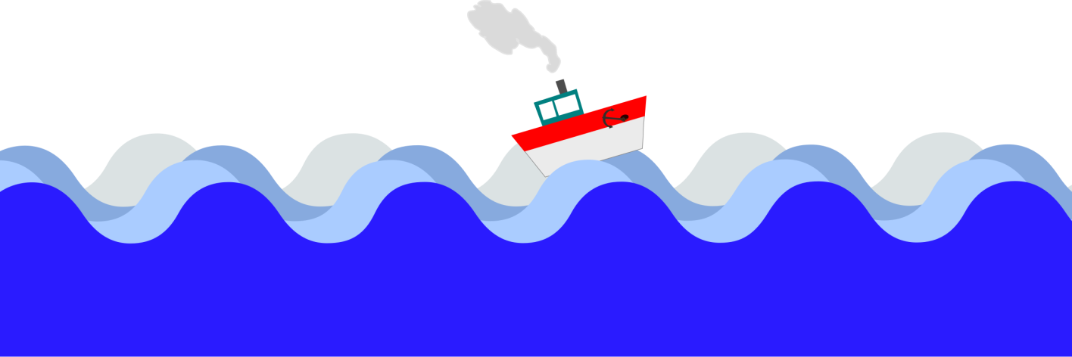
Unit: Make it float!
Name: _____________________
Year: _____________________

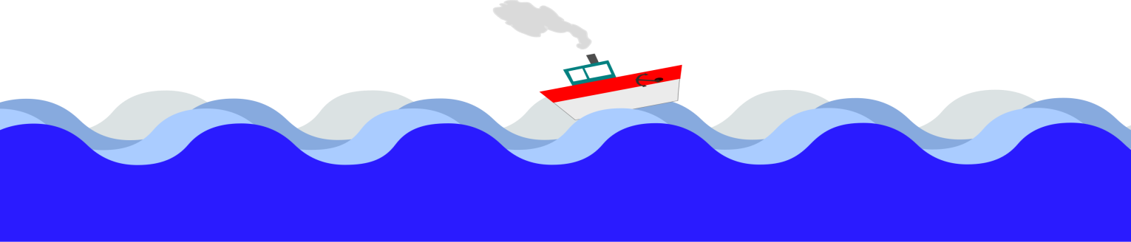

Design Brief: Year 2 Design and Technologies

Fantastic Force: Make it float!
Background
Boats are amazing! They can float and move on water. Boats have many purposes. They can carry hundreds of big shipping containers across the ocean or simply take you onto the lake to go fishing. While boats may vary in size, shape and purpose they all have some key characteristics that make them boats.
The Problem: Our class wants to enter in the miniature boat race at the school fete. The object of the race is to raise funds to donate to Queensland Cancer Council. All boats that are entered must be handmade and able to propel themselves. This class wants to raise the most money this year.
Your challenge
Your challenge is to plan, design and create a boat from everyday materials that is able to float and move on water. You will use the key understandings of design and construction to ensure that your boat floats and moves.
Criteria
- The boat must be made from everyday materials
- You will use a balloon and straw to make your boat move.
- You can decorate your boat to look how you want as well.
Check the rubric to see how you will be marked for this assessment.
Materials for the project
- Everyday materials – plastic bottles, straws and other items (these will be provided).
- Scissors for cutting the materials.
- Glue as required.
What makes a boat float and move?
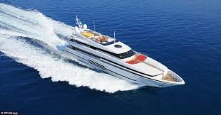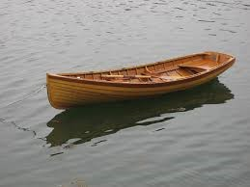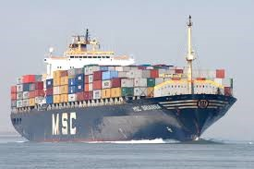

Write 3 things that are the same and 3 things that different about these boats in each of the boxes below:

Draw your boat diagram here.

Where do we see forces in everyday life?
We have watched a short video of forces and have determined that force is basically one object pushing or pulling another object. Work with a partner and create a list of objects that can be pushed or pulled. List or draw your answers below.

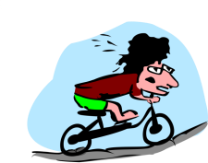

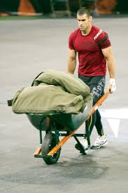

What forces do you know?
- Think of a force that you have seen in action recently. What type of force was it? Explain what you saw.
______________________________________________________________________________________________________________________________________________________________________________________________________________________________________________________________________________________________________________________
- In the space below, draw a picture of the force that you saw.

Identifying the problem
Think about the task you have been given.
What is the task? ______________________________________________________________________________________________________________________________________________________________________________________________________________________________________________________________________________________________________________________
Why are we completing this task? Think back to the first lesson and the design brief to help you remember.
________________________________________________________________________________________________________________________________________________________________________________________________________________________________________________________
Is there a problem that needs to be solved?
____________________________________________________________________________________________________________________________
Explain the problem below
________________________________________________________________________________________________________________________________________________________________________________________________________________________________________________________
How do you think the balloon engine will power the boat and make it move? How is this force?
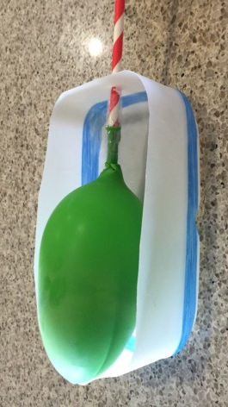
________________________________________________________________________________________________________________________________________________________________________________________________________________________ ________________
Planning your project

Find the matching colour. Write your answer.

Create your design

Time to construct your boat
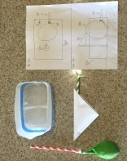
Take photos of your work at the different stages and place them into the correct box.
Materials and design
Final product 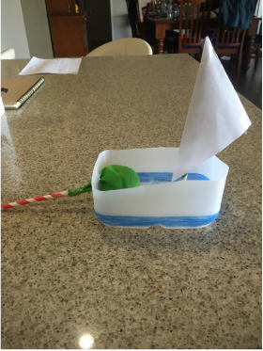

Your boat moving on water:

Evaluating your project
- Did your final product match the design that you created?
______________________________________________________________________________________________________________________

- What products/materials did you use to build your boat?
______________________________________________________________________________________________________________________
- Were these products appropriate for use in the water?
______________________________________________________________________________________________________________________

- Did your boat float?
______________________________________________________________________________________________________________________

- Did your boat move through the water?
______________________________________________________________________________________________________________________

- If anything, what would you change about your boat design to improve it?
______________________________________________________________________________________________________________________

RUBRIC
Fantastic Force: Make it float
NAME:
ASSESSMENT CRITERIA | OUTSTANDING | PROFICIENT | EMERGENT | SATISFACTORY | UNSATISFACTORY
Planning and design of project.  /5 | Student has provided a very detailed design plan of the project including products that will be used and clearly labelled features of the boat.  (5) | Student has provided a clearly detailed design of the project plan which includes products that will be used and clearly labelled features of the boat.  (4) | Student has provided a plan of their boat. The plan includes some information about the products to be used and features that the boat will include.  (3) | Student has provided a plan of the boat. The plan features minor details of the boat features and products to be included.  (2) | Student has provided a plan of the boat. The plan does not feature information about the products or features of the boat.  (0-1)
Construction skills  /5 | Appropriate use of tools and equipment. The final product clearly matches the plan the design that was drawn and includes all relevant features.  (5) | Appropriate use of tools and equipment. The final product matches the designs drawn and includes relevant features.  (4) | Appropriate use of tools and equipment with some assistance required. The final product closely resembles the design plan and includes most of the features outlined in the plan.  (3) | Some understanding of construction and tool use with assistance required. Final product generally resembles the plan with some components missing or added.  (2) | Some understanding of construction and tool use with assistance required. Final product does not match the original plan or has many missing components.  (0-1)
Evaluation of product success  /5 | Student has provided in depth detail of the project success including any changes that they would make to enhance the product.  (5) | Student has provided a clear, detailed discussion about the success of the project including any changes that could be made to enhance the project.  (4) | Student has provided information regarding the success of the project. Some possible enhancements have been mentioned.  (3) | Success of project is not clearly stated with relevant information missing. Student has not provided in depth detail about how the project could enhanced.  (2) | Unclear description of the project provided. Information missing with little to no discussion about the potential improvement of the project.  (0-1)

